**ASSIGNMENT NO 4**

**TITLE:**

LINKED LIST

**PROBLEM STATEMENT**: Second year Computer Engineering class, set A of students like Vanilla Ice-cream and set B of students like butterscotch ice-cream. Write C/C++ program to store two sets using linked list. compute and display-

i. Set of students who like either vanilla or butterscotch or both

ii. Set of students who like both vanilla and butterscotch

iii. Set of students who like only vanilla not butterscotch

iv. Set of students who like only butterscotch not vanilla

v. Number of students who like neither vanilla nor butterscotch

**PRE REQUISITE**:

To implement linked list.

**LEARNING OBJECTIVES:**

Basic operations of linked list.

THEORY:

## Introduction to Linked Lists:

Linked List is a linear data structure and it is very common data structure which consists of group of nodes in a sequence which is divided in two parts. Each node consists of its own data and the address of the next node and forms a chain. Linked Lists are used to create trees and graphs.

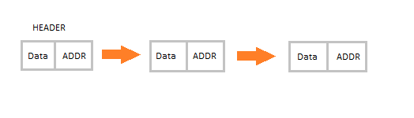

#### Advantages of Linked Lists

* They are a dynamic in nature which allocates the memory when required.
* Insertion and deletion operations can be easily implemented.
* Stacks and queues can be easily executed.
* Linked List reduces the access time.

#### Disadvantages of Linked Lists

* The memory is wasted as pointers require extra memory for storage.
* No element can be accessed randomly; it has to access each node sequentially.
* Reverse Traversing is difficult in linked list.

#### Applications of Linked Lists

* Linked lists are used to implement stacks, queues, graphs, etc.
* Linked lists let you insert elements at the beginning and end of the list.
* In Linked Lists we don’t need to know the size in advance.

#### Types of Linked Lists

* **Singly Linked List :** Singly linked lists contain nodes which have a data part as well as an address part i.e. next, which points to the next node in sequence of nodes. The operations we can perform on singly linked lists are insertion, deletion and traversal.

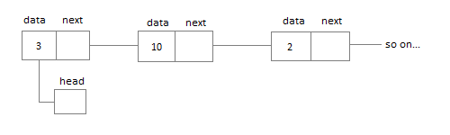

* **Doubly Linked List :** In a doubly linked list, each node contains two links the first link points to the previous node and the next link points to the next node in the sequence.

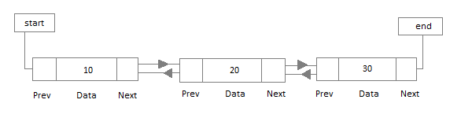

* **Circular Linked List :** In the circular linked list the last node of the list contains the address of the first node and forms a circular chain.

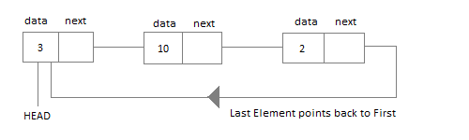

## Linear Linked List

The element can be inserted in linked list in 2 ways :

* Insertion at beginning of the list.
* Insertion at the end of the list.

We will also be adding some more useful methods like :

* Checking whether Linked List is empty or not.
* Searching any element in the Linked List
* Deleting a particular Node from the List

Before inserting the node in the list we will create a class **Node**. Like shown below :

class **Node** {

public:

int data;

*//pointer to the next node*

node* next;

**node**() {

data = 0;

next = NULL;

}

**node**(int x) {

data = x;

next = NULL;

}

}

We can also make the properties data and next as private, in that case we will need to add the getter and setter methods to access them. You can add the getters and setter like this :

int **getData**() {

return data;

}

void **setData**(int x) {

this.data = x;

}

node* **getNext**() {

return next;

}

void **setNext**(node *n) {

this.next = n;

}

Node class basically creates a node for the data which you enter to be included into Linked List. Once the node is created, we use various functions to fit in that node into the Linked List.

#### Linked List class

As we are following the complete OOPS methodology, hence we will create a separate class for **Linked List**, which will have all its methods. Following will be the Linked List class :

class **LinkedList** {

public:

node *head;

*//declaring the functions*

*//function to add Node at front*

int addAtFront(node *n);

*//function to check whether Linked list is empty*

int isEmpty();

*//function to add Node at the End of list*

int addAtEnd(node *n);

*//function to search a value*

node* search(int k);

*//function to delete any Node*

node* deleteNode(int x);

**LinkedList**() {

head = NULL;

}

}

#### Insertion at the Beginning

Steps to insert a Node at beginning :

1. The first Node is the Head for any Linked List.
2. When a new Linked List is instantiated, it just has the Head, which is Null.
3. Else, the Head holds the pointer to the first Node of the List.
4. When we want to add any Node at the front, we must make the head point to it.
5. And the Next pointer of the newly added Node, must point to the previous Head, whether it be NULL(in case of new List) or the pointer to the first Node of the List.
6. The previous Head Node is now the second Node of Linked List, because the new Node is added at the front.

int LinkedList :: **addAtFront**(node *n) {

int i = 0;

*//making the next of the new Node point to Head*

n**->**next = head;

*//making the new Node as Head*

head = n;

i++;

*//returning the position where Node is added*

return i;

}

#### Inserting at the End

Steps to insert a Node at the end :

1. If the Linked List is empty then we simply, add the new Node as the Head of the Linked List.
2. If the Linked List is not empty then we find the last node, and make it' next to the new Node, hence making the new node the last Node.

int LinkedList :: **addAtEnd**(node *n) {

*//If list is empty*

if(head == NULL) {

*//making the new Node as Head*

head = n;

*//making the next pointe of the new Node as Null*

n**->**next = NULL;

}

else {

*//getting the last node*

node *n2 = **getLastNode**();

n2**->**next = n;

}

}

node* LinkedList :: **getLastNode**() {

*//creating a pointer pointing to Head*

node* ptr = head;

*//Iterating over the list till the node whose Next pointer points to null*

*//Return that node, because that will be the last node.*

while(ptr**->**next!=NULL) {

*//if Next is not Null, take the pointer one step forward*

ptr = ptr**->**next;

}

return ptr;

}

#### Searching for an Element in the List

In searching we do not have to do much, we just need to traverse like we did while getting the last node, in this case we will also compare the **data** of the Node. If we get the Node with the same data, we will return it, otherwise we will make our pointer point the next Node, and so on.

node* LinkedList :: **search**(int x) {

node *ptr = head;

while(ptr != NULL && ptr**->**data != x) {

*//until we reach the end or we find a Node with data x, we keep moving*

ptr = ptr**->**next;

}

return ptr;

}

#### Deleting a Node from the List

Deleting a node can be done in many ways, like we first search the Node with **data** which we want to delete and then we delete it. In our approach, we will define a method which will take the **data** to be deleted as argument, will use the search method to locate it and will then remove the Node from the List.

To remove any Node from the list, we need to do the following :

* If the Node to be deleted is the first node, then simply set the Next pointer of the Head to point to the next element from the Node to be deleted.
* If the Node is in the middle somewhere, then find the Node before it, and make the Node before it point to the Node next to it.

node* LinkedList :: **deleteNode**(int x) {

*//searching the Node with data x*

node *n = **search**(x);

node *ptr = head;

if(ptr == n) {

ptr**->**next = n**->**next;

return n;

}

else {

while(ptr**->**next != n) {

ptr = ptr**->**next;

}

ptr**->**next = n**->**next;

return n;

}

}

#### Checking whether the List is empty or not

We just need to check whether the **Head** of the List is NULL or not.

int LinkedList :: **isEmpty**() {

if(head == NULL) {

return **1**;

}

else { return **0**; }

}

If you are still figuring out, how to call all these methods, then below is how your main() method will look like. As we have followed OOP standards, we will create the objects of **LinkedList** class to initialize our List and then we will create objects of **Node** class whenever we want to add any new node to the List.

int main() {

LinkedList L;

*//We will ask value from user, read the value and add the value to our Node*

int x;

cout << "Please enter an integer value : ";

cin >> x;

Node *n1;

*//Creating a new node with data as x*

n1 = new Node(x);

*//Adding the node to the list*

L.addAtFront(n1);

}

Similarly you can call any of the functions of the LinkedList class, add as many Nodes you want to your List.